ALBA Membership Quick Guide

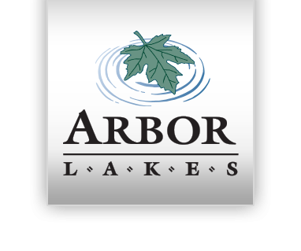
The Arbor Lakes Business Association (ALBA) membership network spans across all the Arbor Lakes Districts. This includes, Main Street, The Fountains at Arbor Lakes, The Shoppes at Arbor Lakes, The Arbor Lakes Medical Building, Great River Energy, The Village at Arbor Lakes and area hotels. Each of these districts has multiple landlords and business owners. The goal of ALBA is to combine the marketing efforts across all districts and showcase Arbor Lakes as one unified entity.

ALBA membership is $630 annually and with it, you will be receiving many benefits valued well over $3,000 each year!

Marketing:
ALBA creates a trusted resource for your consumers. The association increases your marketing reach with organized events, website traffic and a large social media community. When faced with a limited marketing budget, ALBA can do some of the talking and promoting for you. The association already has a narrative for your industry and the community in which you thrive. Please see next page for full list of marketing benefits.

Networking:
The most successful entrepreneurs aren’t afraid to network with competitors as well as their peers. ALBA offers a bridge to communicate with associates and competitors in a collaborative environment. By combining voices under one banner, companies will establish a strong and unified presence and effectively protect their shared interests. ALBA creates and maintains strategic alliances with businesses and property owners. ALBA also offers periodic meet ups for introducing new members and networking opportunities.

Approximately 85 percent of all business failures occur in firms that are not members of their trade [local business] association. One of the biggest advantages of association membership is networking and camaraderie.
~American Business Magazine March 5, 2010

Advertising and Promotion:
- Exclusive listing opportunities in advertisements, posters, and event guides
- Arbor Lakes Savings Book inclusion and discounted rates on publication produced by ALBA
- Free opportunity to promote in the ALBA monthly Newsletter. This creates exposure to over 150 businesses in the Arbor Lakes community
- Arbor Lakes Map – includes all phases/components of Arbor Lakes and sponsorship opportunities
- Access to certain events and promotions at The Shoppes at Arbor Lakes at the discretion of mall management
- Cooperative advertising opportunities with discounted member rates
- www.ArborLakes.net
  - Expanded member bios
  - Highlighted logo placements
  - Free listings for events and special offers
  - Interact with and grow the social media community. Social media exposure; free promotions and updates on the Arbor Lakes Facebook page and Twitter
  - Businesses will be linked directly to Google Maps and member websites to drive traffic, increase awareness, and exposure
  - Continuous growth expectations for website traffic and social media community

ALBA 2019 Events and Publication Guide

Fall Festival on Main Street
- Name of the ad/event: Fall Festival on Main Street
- Date(s) of the publication/event: Saturday before Halloween-- 10:00am-2:00pm
- Cost to participate:
  - Free for ALBA members (Non-Members fee is $500)
  - Sponsorship opportunities available on Participation form.
- Supporting materials needed/what type of event is it: This is a Trick or treat event. You will need candy and whatever other promotional materials you would like to hand out. Activities outside and in-store are encouraged. Attendance for 2018 was around 1,500-2,000.
- Deadline to participate: Date on Participation form. Usually the deadline to sign up is two-three weeks before the event.
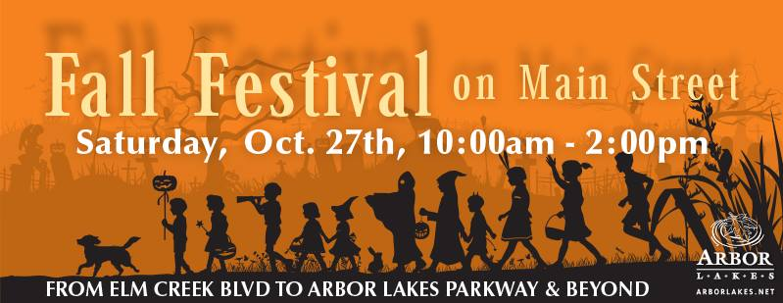
2018 Social Media header

Arbor Lakes Savings Book
- Name of the ad/event: Arbor Lakes Savings Book
- Date(s) of the publication/event: Available to the public close to January 1st every year
- Cost to participate:
  - 1/2 ad= $250 for ALBA Members. ($500 for Non-Members).
  - Full Page, Full color ad = $1000 for everyone
- Supporting materials needed/what type of event is it: This book features your business’s coupons and has opportunity for full color ads. 30,000+ books are distributed every year from the Shoppes’ Guest Services, through local hotels, to tour groups, and at local community events.
- Deadline to participate: Date on Participation form. Usually the deadline to sign up is in the beginning of December.
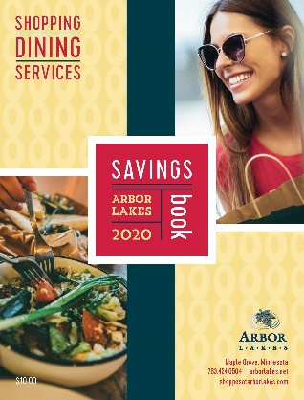
2020 Cover art

ALBA Online Auction
- Name of the ad/event: ALBA Online Auction
- Date(s) of the publication/event: 10 days in early-November
- Cost to participate: All we need for this event is a donation of goods or services. (Ex. Gift certificates, goodie baskets, free service)
- Supporting materials needed/what type of event is it: ALBA is a non-profit organization, therefore we have to rely on dues and fundraisers in order to create our marketing budget. This online auction is the biggest fundraiser we produce for ALBA. Businesses donate items that involve their store and we auction them off to online participants throughout the course of 10 days. Last year we raised around $1,700 to go towards ALBA expenses.
- Deadline to participate: Date on Participation form. Usually the deadline is a week before the auction goes live.
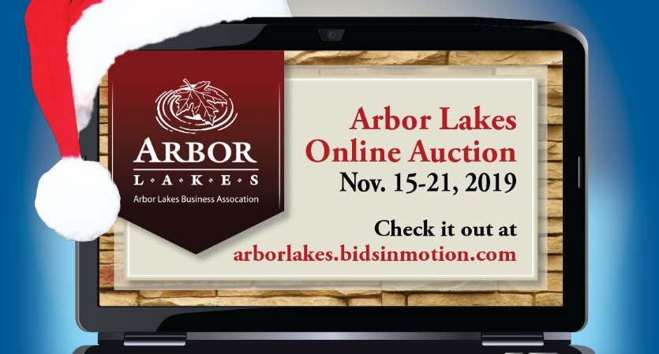2019 Social Media Header

Hometown Holiday on Main Street
- Name of the ad/event: Hometown Holiday on Main Street
- Date(s) of the publication/event: First Saturday in December, from 3:30pm - 6:30pm
  - Cost to participate: Free for ALBA Members ($500 for Non-members)
  - Sponsorship options available
- Supporting materials needed/what type of event is it: Feel-good holiday event. Features include horse-drawn trolley rides, hot cocoa, music, a community tree lighting and we produce the Sleighbells &d Sparkle Parade that goes down Main street of Arbor Lakes. Attendance is around 1,000-2,000 each year (Weather dependent)
- Deadline to participate: Date on Participation form. Usually the deadline is two-three weeks before the event.
2019 Social Media Header

Chalkfest at Arbor Lakes

- Name of the ad/event: Chalkfest at Arbor Lakes
- Date(s) of the publication/event: June 13—14, 2020
- Cost to participate: ALBA Members can be on the street for free (Non-members pay $500) and receive discounts on supporting sponsorships.
- Supporting materials needed/what type of event is it: This is the biggest

ALBA event we produce; sponsorships are again, not required, but HIGHLY encouraged from ALBA members. This event brings in artists from all around the world to create masterpiece chalk art all up and down Main Street. This event draws around 20,000-30,000 people per year regardless of weather.
- Deadline to participate: May 1st, 2020

2020 Social Media Header

Additional Benefits in 2020

- ALBA has partnered with the I-94 West Chamber of Commerce to offer $99 memberships to the Chamber for all members of the Arbor Lakes Business Association.
- ALBA is facilitating Business Mixers to help our members to connect with one another in a social setting.
- ALBA is once again establishing a business to business (B2B) network of ALBA members to encourage sharing of promotional materials and cross-promotion between members.

- ALBA will be developing a newsletter to be distributed to our database developed from event guests who have opted-in to our mailing list. Members will advertise for free in this publication.
- ALBA will be changing our website format to allow member advertising.
